Worksheet Bits & Bytes


Items highlighted in yellow are tasks for you to complete
Items in Blue italics are help tips

Digital system/s
Digital hardware and software components (internal and external) used to transform data into digital solutions. When digital systems are connected, they form a network.

Data
In Digital Technologies, data refers to the discrete representation of information using number codes. Data may include characters (e.g. alphabetic letters, numbers and symbols), images, sounds and/or instructions that when represented by number codes can be manipulated, stored and communicated by digital systems. For example, characters may be represented using ASCII code or images may be represented by a bitmap of numbers representing each ‘dot’ or pixel.

- What is a bit? What is a byte?

A bit is the smallest unit of information within a computer. A. byte is a number made up of 8 digits (all of which are either 0 or 1) and is enough space to save a single letter or symbol. Eg 10010010

- What are the only values that a bit can have?

The only values that a Bit can have are “0” or “1”.

- What is Binary? How do we show numbers in 8-bit binary?

Binary (a Series of 1s and 0s) is the language that all computers speak. These symbols come together to form saved data and instructions for your computer to read and use.

00000000 11111111

- Numbers (for this one, convert the following numbers from decimal to 8-bit binary: 0, 1, 2, 3, 4, 5, 6, 7, 8, 9, 10, 12, 15, 16, 20, 23, 24, 25, 32, 40, 45, 50 – hint: stick them in a table to make it easier)
0 | 000000000
1 | 000000001
2 | 000000010
3 | 000000100
4 | 000001000
5 | 000010000
6 | 000001010
7 | 000001100
8 | 000010000
9 | 000010001
10 | 000010010
12 | 000011000
15 | 000011100
16 | 000100000
20 | 000101000
23 | 000101100
24 | 000110000
25 | 000110001
32 | 001000000
40 | 001010000
45 | 001010110
50 | 001100010

- What does ASCII stand for?

American Standard Code for Information Interchange

- Why do we use ASCII?

ASCII was intended to be used by people across the world in an attempt to give all computers (and their programmers) a common language, allowing them to share documents and files with less confusion

- Example (for this one get an image of an ASCII Code to Binary chart)

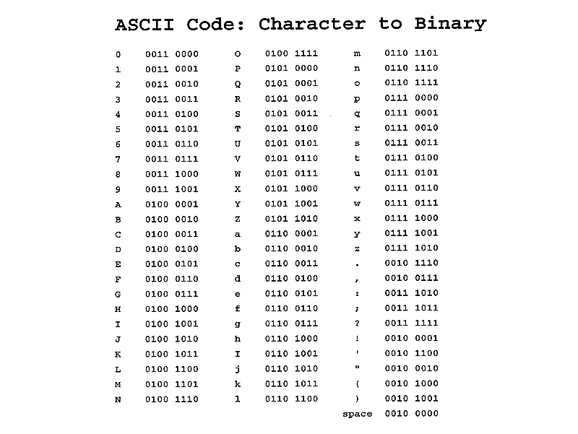

- What is Unicode, and what does it attempt to represent in terms of language?

Unicode uses 16 bits to code for all the letters and symbols commonly used in today’s digital and print media. Unicode has become the top standard for identifying characters in text in nearly any language.

- What is the difference between embedding and linking multimedia (such as a video)?

In the case of linking, the data gets stored in the source file and is updated there whenever a change occurs in the linked file. In embedding, the data is stored in your file and any updates in the original source file are not reflected.

